 |  |  |   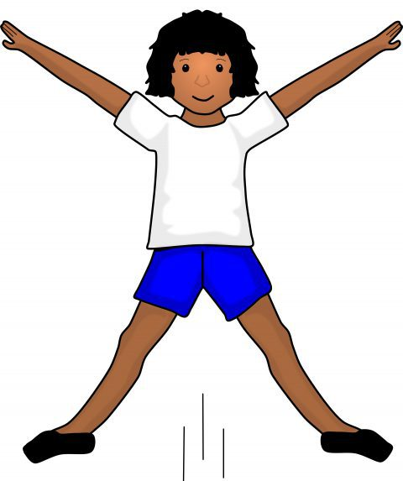  Stay Active Week
Week 1 | Mon 24th July | Tues 25th | Weds 26th | Thursday 27th | Fri 28th
Open 8am  9:30am | Bread Making  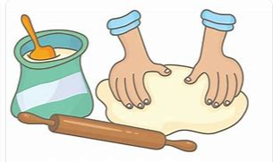 |   Walking trip to Yate Library |   RNLI Workshop  (9am onwards)  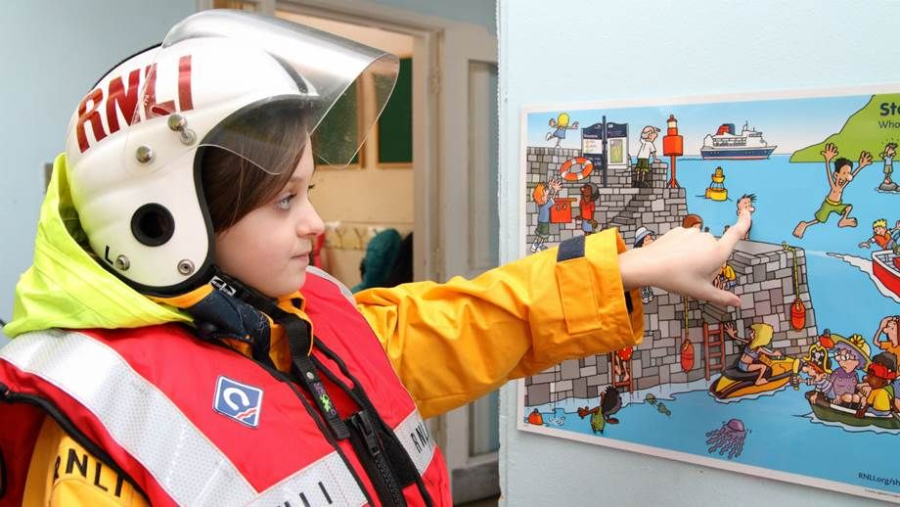  We will be learning about water safety and enjoying some activities | Giant Junk Modelling   | Shaving Foam Play  
10:30am |  |  |  |  | 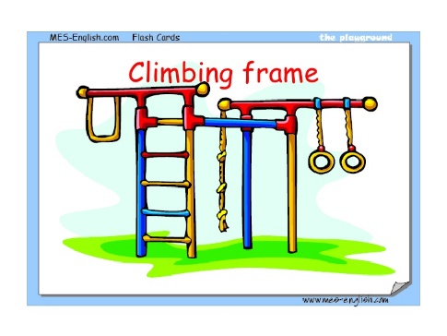  Park Play
12:00pm | Lunch time    Please pack a  healthy lunch box  with an ice pack |   Yate Sandpit Fun
1:00pm |  |  |     to Ridge Woods  (Please remember suncream and a hat) | Create Your Own Fruit Kebab Snack! | Air Hockey Time  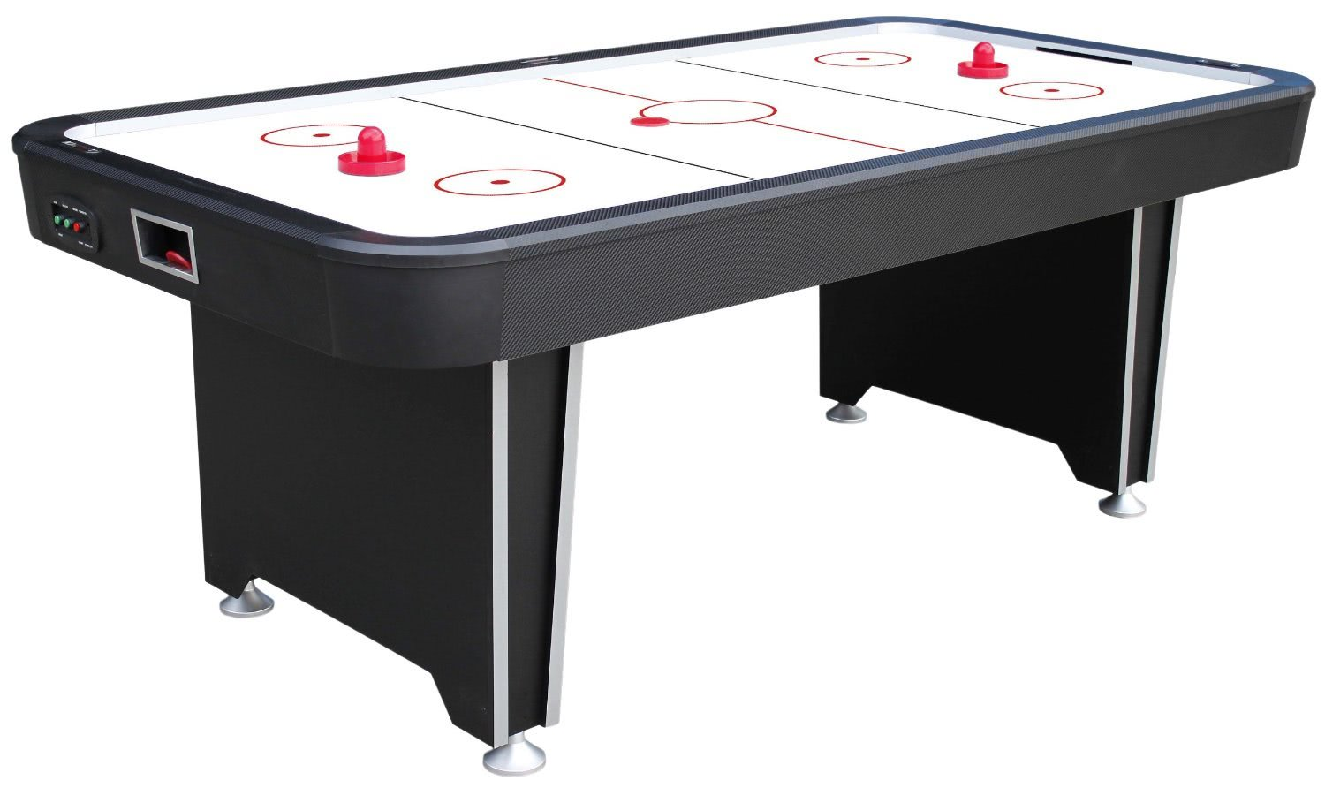
2:30pm | Penalty Shoot Out   | Jelly Play   |  | Disco Time  
2:30pm |  |  | Circle Games   |  | 
4:00pm  Close 6pm | Wii Dance   | 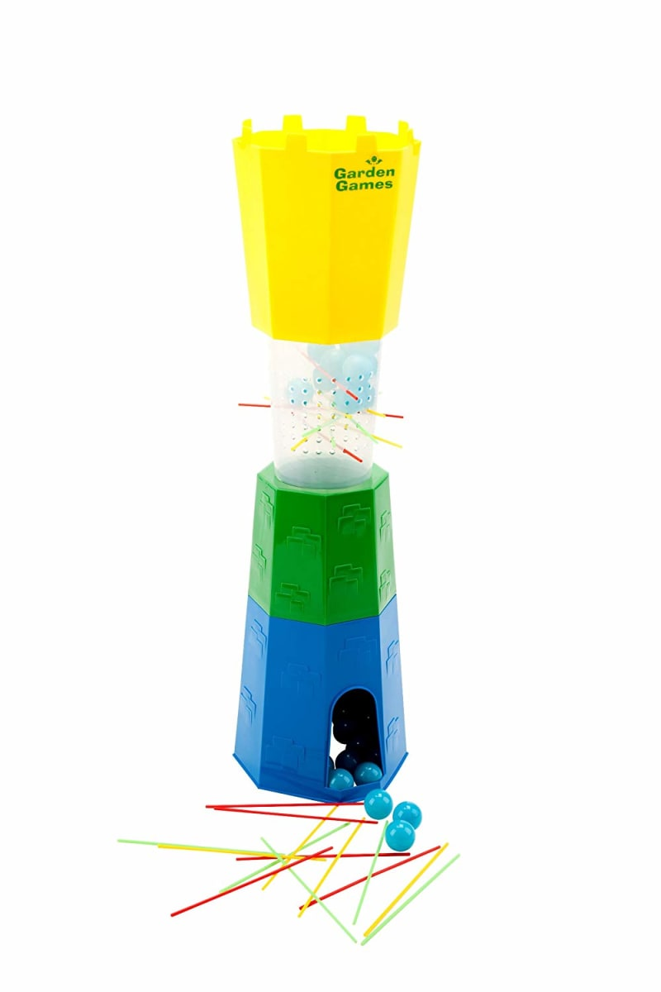  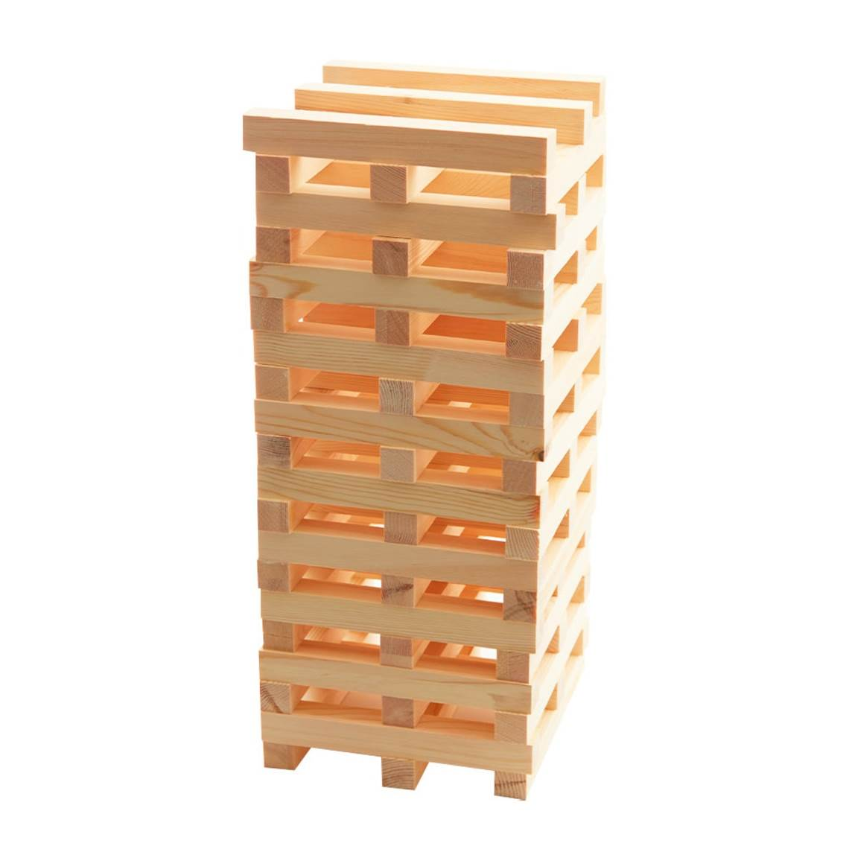  Games   |  |   Hula Hoop Fun | Back to School  We return for After School Club in September. Please book any September After School Club places before Friday August 18th –  Thank you!



Multi-Cultural Week

Week 2 | Monday 31st July | Tuesday 1st August |  |  | Wednesday 2nd |  |  |  |  | Thursday 3rd |  |  |  | Friday 4th
Open  8am  9:30am |     Drumming Workshop |   Fudge Making |  |  |   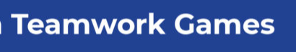 |  |  |  |  |   Walking trip to Yate Library |  |  |  | Park Play  
10:30am | Yate Sandpit Fun | Painting  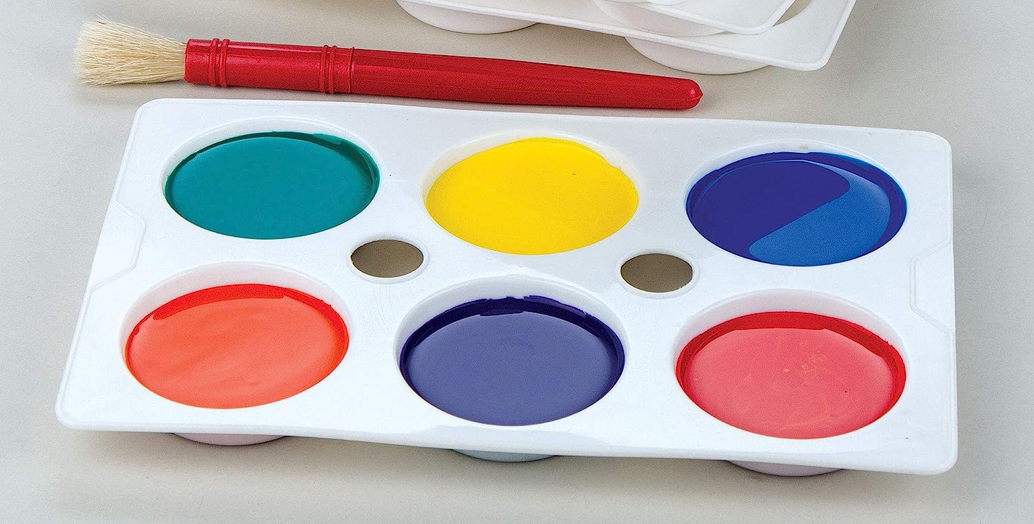 |  |  |  |  |  |  |  |  |  |  |  | Sensory Playdough    With added extras – see if you can guess what they are!
12:00pm |  |  |  |  | Animation Workshop    Create your own animated scene using plasticine
1:00pm | Games Around the World  (Parachute games & more!)   | British Bulldog  Playground Game    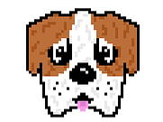
2:30pm |  |  |  |  |  |  |  |  |  |   African Masks |  |  |  | Magnetic Darts  
4:00pm  Close 6pm | 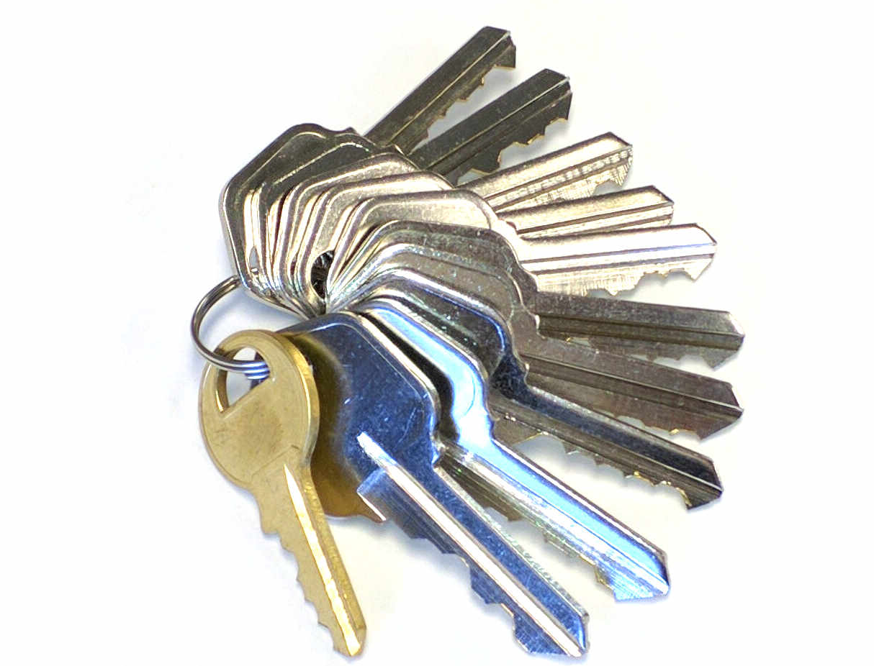  The Key Game | 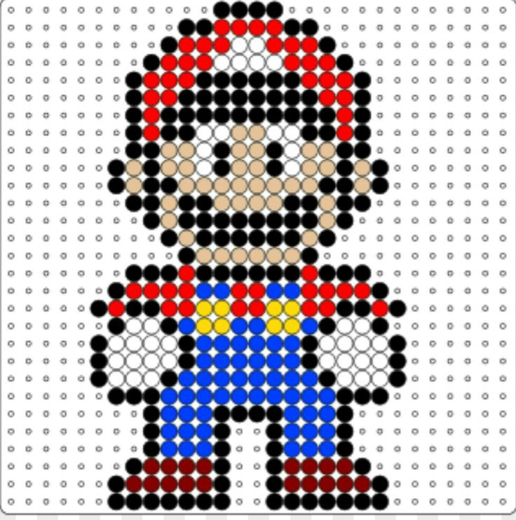  Hama Beads |  |  |   Henna Designs |  |  |  |  |   Musical Chairs

Wink Wink Murder



Well-Being Week

Week 3 | Monday 7th | Tuesday 8th |  | Wednesday 9th |  |  |  | Thursday 10th |  |  | Friday 11th
Open 8am  9:30am |   Walk to Shops | Carrot Cake Making   |  | 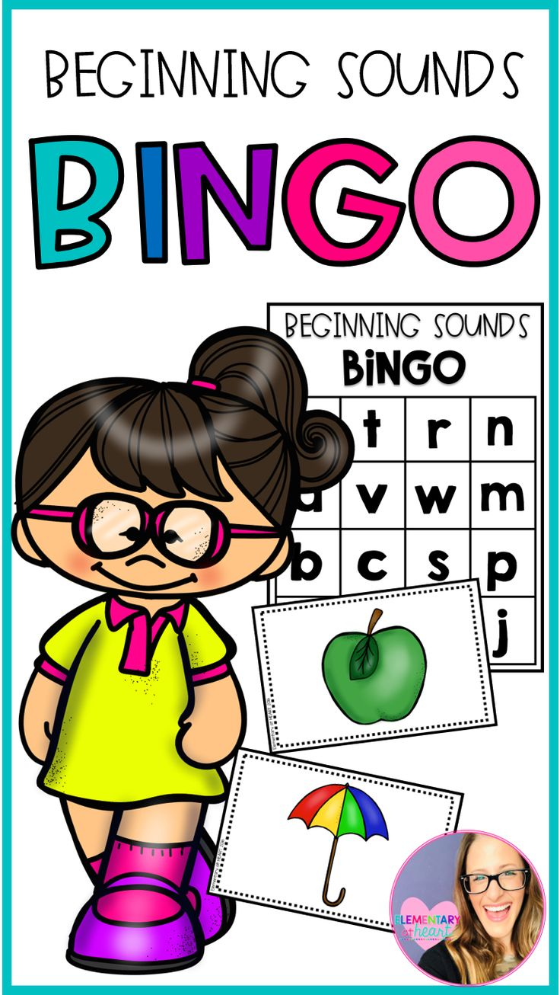       |  |  |  | Yate Sandpit Fun |  |  |   Jelly Play

Basketball

12:00pm | Lunch time  With an ice pack please!
1:00pm |   Diwali Lantern Making |   Party Games |  |   Hide & Seek |  |  |  | Self-Care time  (Discovering what we love and why we should do it!)   |  |  | After 12pm Lunch:  Listening to the Wonderful Sound of Rain –  Friday Wind Down  
2:30pm | Dance Workshop   | 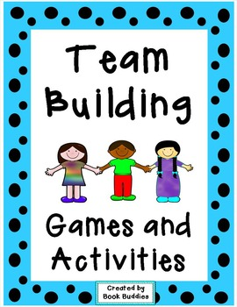 |  |   Children’s Yoga Session |  |  |  | 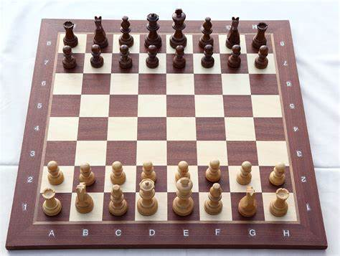  How to  Play  Chess
4:00pm  Close  6pm |   Pool Tournament |  |  |   Chill Out Time |  |  |  |   Mindfulness |  |  | Stick Man Story &    Picture Making


Express Yourself Week
Week 4 | Monday 14th | Tuesday 15th | Wednesday 16th |  |  |  | Thursday 17th |  |  |  |  | Friday 18th
Open  8am  9:30am | Needlecraft  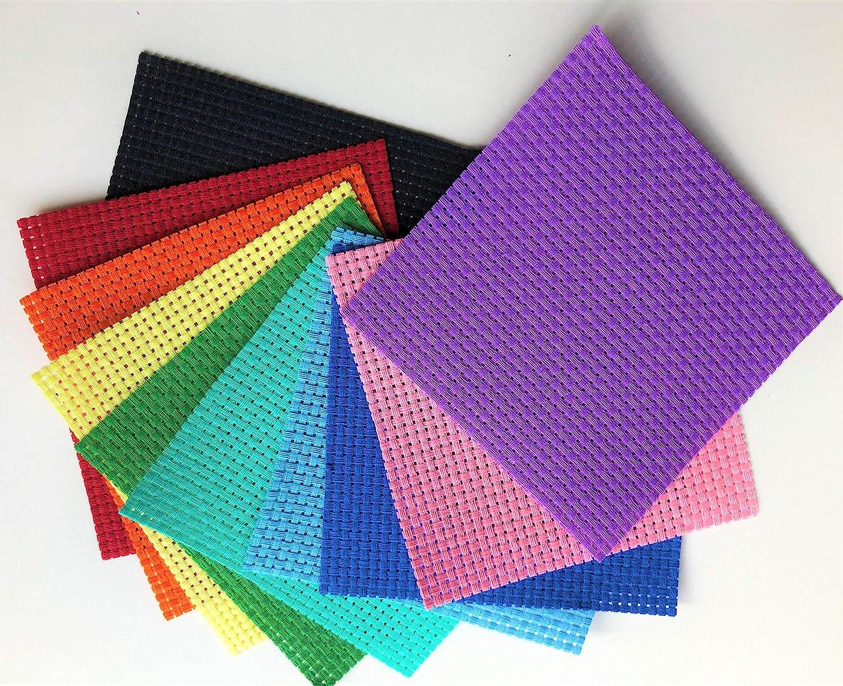 | 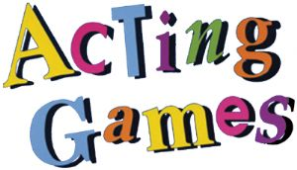 |   Spotting the Signs of Mental ill Health |  |  |  | 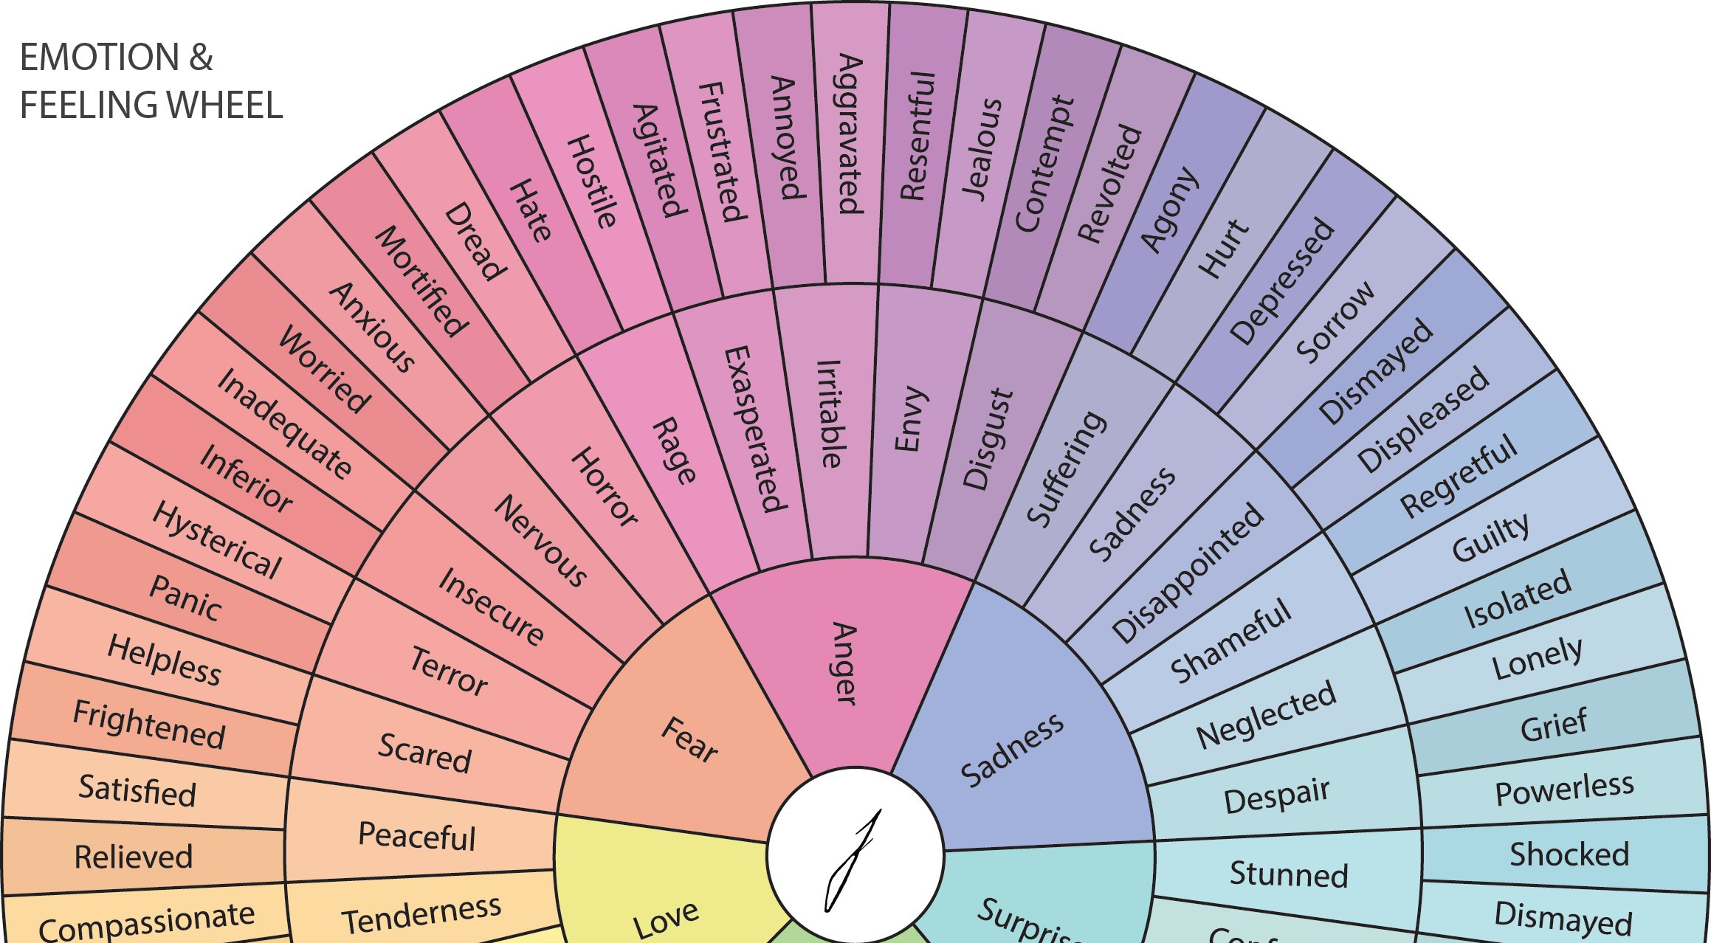  Emotions Wheel |  |  |  |  | Walking trip to Yate Library
10:30am | Park Play    Picnic in the Park | Football   |   Bouncy Ball Fun at the Park |  |  |  | Basketball   |  |  |  |  | Coloured Water & Ice Play  
12:00pm | Lunch time |  |   Sand Bottles |  |  |  |     Poetry Writing |  |  |  |  |   Emotions Paintings  Exploring our feelings whilst we paint
2:30pm | Darts
4:00pm  Close  6pm |   Splatter Painting |   Chalk Pictures |  |  |  |  |  |  |  |  |  |   Sandcastle Play
4:00pm  Close  6pm |  |  |  |  |  |  |   

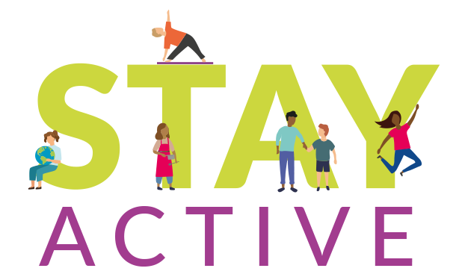
Healthy Lifestyles Week
Week 5 | Monday 21st | Tuesday 22nd |  |  |  | Wednesday 23rd |  |  | Thursday 24th |  |  |  | Friday 25th
Open  8am  9:30am |   Coping With Anxiety | Walk to Ridge Woods for a very exciting …   |  |  |  | Sensory Walk   |  |  |   Hobby Time |  |  |  | 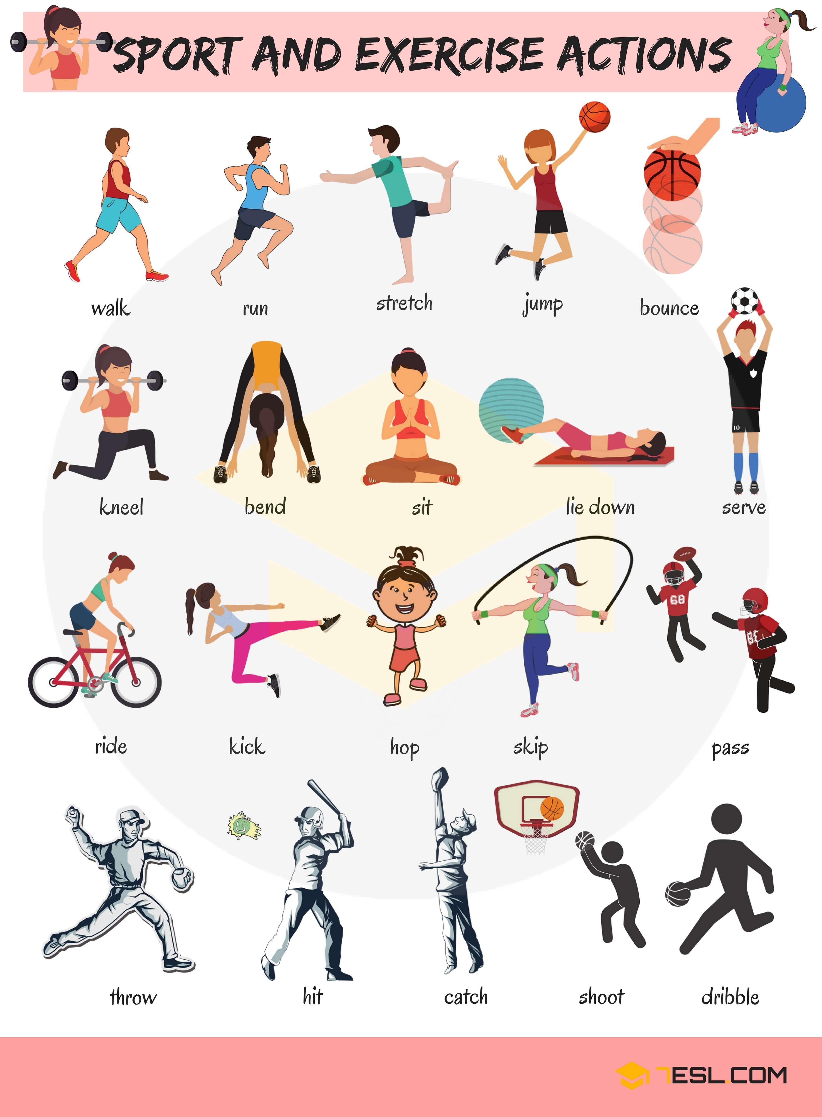  Find your favourite activity!
Open  8am  9:30am |  |   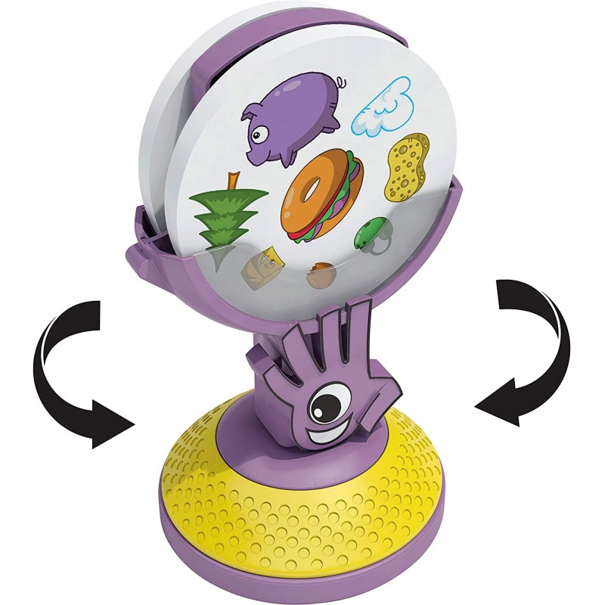 |  |  |  | 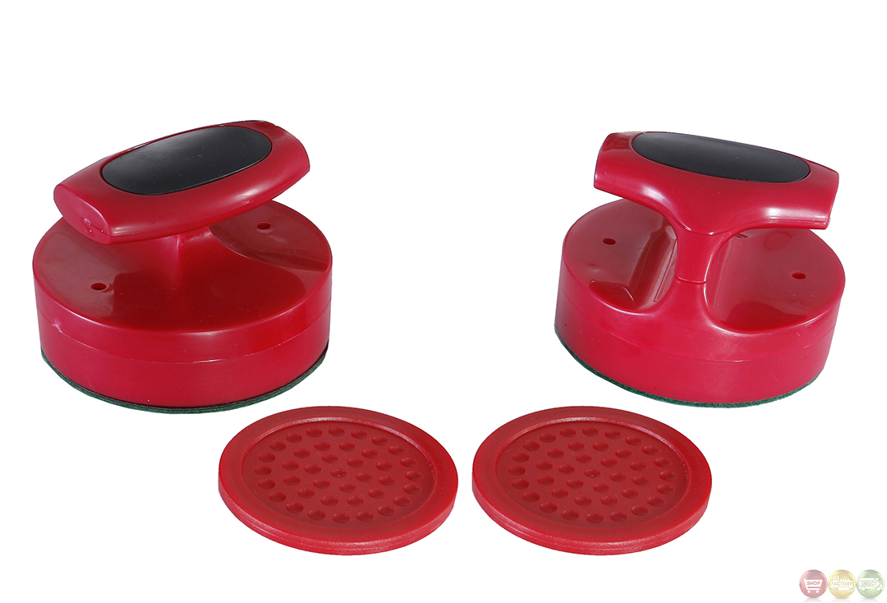  Air Hockey |  |  |  |  |  |  | Moon Sand Play  
12:00pm | Lunch time |  |  |  |  |  |  |  | Combat Stress  
1:00pm | Messy Play  
2:30pm | Skipping Challenges  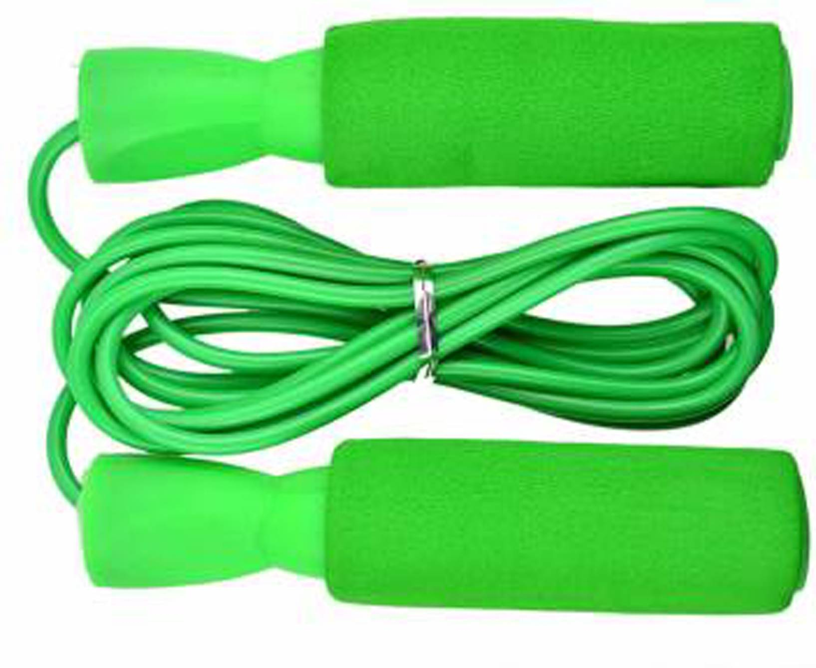 | Fruit Kebab making all week for snack times |  |  |  |     Gardening |  |  |   Hockey |  |  |  |   Restful Activities
2:30pm |  | 
4:00pm  Close 6pm |   Pasta Pictures | Balloon Tennis     |  |  |  | 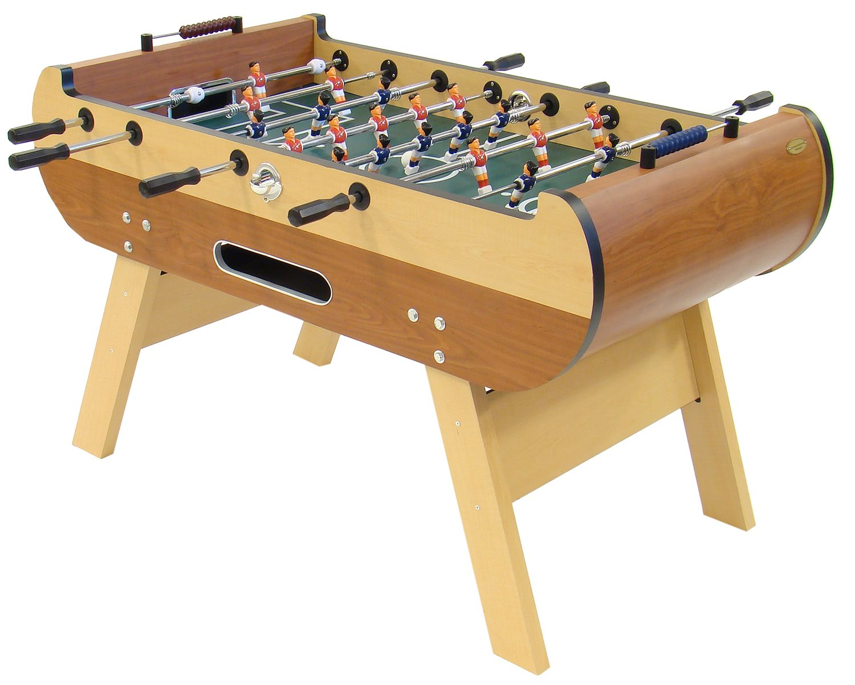  Table Football |  |  |   Technology Time |  |  |  | Sleeping Lions  Wind Down Game


I.C.T Week

Week 6 | Monday 28th August | Tuesday 29th |  | Wednesday 30th |  |  | Thursday 31st |  |  |  |  | Sept 1st
Open  8am | BANK HOLIDAY –  CLUB CLOSED |     Karaoke Fun |  | Remote Control Fun   |  |  |   Meringue Making |  |  |  |  | CLUB CLOSED
10:30am
12:00 pm | BANK HOLIDAY –  CLUB CLOSED |  |  |  |  |  | ICT Walk (Hunt)   |  |  |  |  | This Summer we are focusing on anxiety, stress, health and well-being along with other topics relating to staying both physically and mentally well.
1:00pm | Bookings and September Allocated Places  Our Club Owner Sian will be working at another job  throughout the holidays so  if you cannot get through to  her on 07531 344 549 then  please email us or in an emergency, phone Manager  Angela on 07584 040 617.  A September Allocated places  pack can be found online at www.wildaboutplay ridgewood.co.uk.  Any September adhoc bookings  can be accepted once a booking email has been confirmed via invoice. |   Park Play |  |   Exercise Session
2:30pm |  |   Photography Workshop |  | Junk Modelled    Technology |  |  |   Basketball |  |  |  |  | 
4:00pm  Close 6pm |  | String Paintings   |  |   Walkie Talkie Fun |  |  | End of Holiday Disco   |  |  |  |  | Stay Safe Online talks throughout the Summer  

Summer 2023 Holiday Club Booking Form
Date  Please tick your selected sessions | Morning Session  (8am-1pm)  £15.30 |  |  | Afternoon Session  (1pm-6m)  £15.30 |  |  | All Day Care  (8am-6pm)  £23.30
Mon 24th July
Tues 25th
Weds 26th
Thurs 27th
Fri 28th
Mon 31st
Tues 1st August
Weds 2nd
Thurs 3rd
Fri 4th
Mon 7th
Tues 8th
Weds 9th
Thurs 10th
Fri 11th
Mon 14th
Tues 15th
Weds 16^{h}
Thurs 17th
Fri 18th
Mon 21st
Tues 22nd
Weds 23rd
Thurs 24th
Fri 25th
Mon 28th | Bank Holiday - Closed
Tues 29th
Weds 30th
Thurs 31st
Please note that we are closed for Bank Holiday Monday 28th August.
We welcome suggestions for competitively priced trips and visitors to continue to keep fees low.
By booking with us, you are giving your consent for Wild About Play staff to take your child/children off Club premises, to travel on foot or by insured vehicle to the stated trip destination or take part in a particular activity. If you do not wish your child to take part in face painting, please state this on the day. Some last-minute local outings may be arranged depending on weather, numbers of children and transport.
The booking deadline is Friday July 7th
Name/s of Children: |  |  |  |  | Age/s during the Summer Holidays:
Name of parent/carer: |  |  |  |  | Telephone number:
Home Address:
(House number & post-code)
Email address: |  |  |  |  | School:
Please circle payment  type: |  | BACS |  |  | Childcare Vouchers
Signature: |  |  |  |  | Date:
Are you hoping to receive Holiday Activities & Food (HAF) Holiday Club funding due to low income related free school meals/SEN?
YES/NO
We shall email you instructions on how to book

The Booking Deadline is Friday 9th July. For September After School Club places please book by August 20th at the very latest. All booked care should be paid for in advance and by the invoice due date – Thank you

