Easter 2024
Holiday Programme

April | Tues 2nd | Weds 3rd | Thurs 4th | Fri 5th | Good Friday 29th March &  Easter Monday 1st April  Club Closed  Bank Holidays
Open 8am |  | 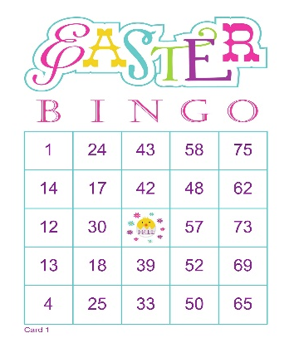  Easter Bingo | Veggie Pizza Making | Park Play
9:30am  10:30am | Yate Library  10.30am Craft Session
HAF

FREE HOLIDAY SESSIONS FOR ELIGIBLE CHILDREN

We have secured funding for Easter & Summer Holiday Club sessions!

Please email us (with your Membership Form if you are new) and a booking form and once you are a member, we can send you the online booking link to secure your place!

Email us on: wapridgewood@yahoo.co.uk

12:00pm |  |  | 12pm - Healthy lunch box required with ice pack please!
 | Dodgy Doodles Competition | Nature Walk – Ridge Woods | Games Time | 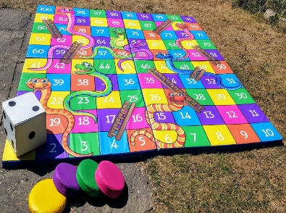  Snakes & Ladders
1:00pm
2:30pm | Origami | Disco Time
4:00pm  Close 6pm |  |  | Messy Foam Play | Ribbon Dancing
If you are hoping to request Holiday Activities & Food (HAF) Holiday Club funding due to low income related free school meals,
we shall email you instructions on how to book via a Eequ booking link if we secure funding and request your child’s free lunch preferences

Easter 2024
Holiday Programme

April | Mon 8th | Tues 9th | Weds 10th | Thurs 11th | Fri 12th
Open 8am |  | Cornflour Gloop | Bubble Egg Paintings | Decorate A Bag | Symmetrical Paintings
9:30am  10:30am | Loom Bands
 |  | The Key Game |  |  | 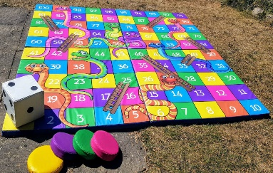  Indoor Hockey
12:00pm | Hula Hooping |  | 12pm - Healthy lunch box required with ice pack please!
 |  | Tiddly Winks | Fidget Toys & Pin Art | Hama Beads
1:00pm |  |  |  |  | Circle Games
2:30pm | Scratch Shapes & Fingerprints Fun | Italian Healthy  Pizza Making
4:00pm  Close 6pm |  |  | Skipping Challenges | Fruit Salad  Parachute Games | Challenges
www.wildaboutplayridgewood.co.uk
Onsite Mobile (Staff team): 07784 48 10 32 The booking deadline is Thursday 21st March Text: Sian (Owner) 07531 344 549

Easter 2024 Holiday Programme
Date  Please tick your selected sessions | Morning Session  (8am-1pm)  £16.30 |  |  | Afternoon Session  (1pm-6pm)  £16.30 |  |  |  | All Day Care  (8am-6pm)  £24.30
Tues 2nd
Weds 3rd
Thurs 4th
Fri 5th
Mon 8th
Tues 9th
Weds 10th
Thurs 11th
Fri 12th
Please note that trips are compulsory and there will not be an option of staying at Club.
We welcome suggestions for competitively priced trips and visitors to continue to keep fees low.

By booking certain dates, you are giving your consent for Wild About Play staff to take your child/children off Club premises, to travel on foot, by Club vehicle or public transport to the stated trip destination or take part in a particular activity.
Name/s of Children: |  |  |  |  |  | Age/s during the Easter Holidays:
Name of parent/carer: |  |  |  |  |  | Telephone number:
Home Address:  (House number & Postcode) |  |  |  |  |  | Are you hoping to receive free holiday care from HAF funding (due to having free school meals for low income?) YES / NO
Email address: |  |  |  |  |  | School:
Please circle payment type: |  | BACS |  |  | Childcare Vouchers | Cash no longer accepted |  |  | Cheques no longer accepted
Signature: |  |  |  |  |  | Date:

All booked care (paid by parent/carer) should be paid for in advance and by the invoice due date – Thank you!

